**Blood Donor in Full Stack**

A Project-II Report

Submitted in partial fulfillment of requirement of the

Degree of

**BACHELOR OF TECHNOLOGY in COMPUTER SCIENCE & ENGINEERING**

BY

**Yuvraj Bonde**

**EN19CS3L1029**

Under the Guidance of

**Dr. Nitika Vats**



**Department of Computer Science & Engineering**

**Faculty of Engineering**

**MEDI-CAPS UNIVERSITY, INDORE- 453331**

**May 2022**

**Report Approval**

The project work **“Blood Donor in Full Stack”** is hereby approved as a creditable study of an engineering/computer application subject carried out and presented in a manner satisfactory to warrant its acceptance as prerequisite for the Degree for which it has been submitted.

It is to be understood that by this approval the undersigned do not endorse or approve any statement made, opinion expressed, or conclusion drawn therein; but approve the “Project Report '' only for the purpose for which it has been submitted.

Internal Examiner

Name:

Designation

Affiliation

External Examiner

Name:

Designation

Affiliation

**Declaration**

I/We hereby declare that the project entitled **“Blood Donor In Full Stack”** submittedin partial fulfillment for the award of the degree of Bachelor of Technology in ‘Computer Science Department’ completed under the supervision of **Dr. Nitika Vats, Associate Professor and Department of Computer Science** Faculty of Engineering, Medi-Caps University Indore is an authentic work.

Further, I/we declare that the content of this Project work, in full or in parts, have neither been taken from any other source nor have been submitted to any other Institute or University for the award of any degree or diploma.

**Signature and name of the student(s) with date**

**Certificate**

I/We, **Dr. Nitika Vats** certify that the project entitled **“Blood Donor in Full Stack”** submittedin partial fulfillment for the award of the degree of Bachelor of Technology by **Yuvraj Bonde** istherecordcarried out by him/them under my/our guidance and that the work has not formed the basis of award of any other degree elsewhere.

________________________________

Dr. Nitika Vats

Computer Science Department

Medi-Caps University, Indore

________________________________

Mr. Akshay Mahajan

Uni-Info Telecom Services Pvt. Ltd

_____________________

Dr. Pramod S. Nair

Head of the Department

Computer Science & Engineering

Medi-Caps University, Indore

**Offer Letter of the Project work-II/Internship**

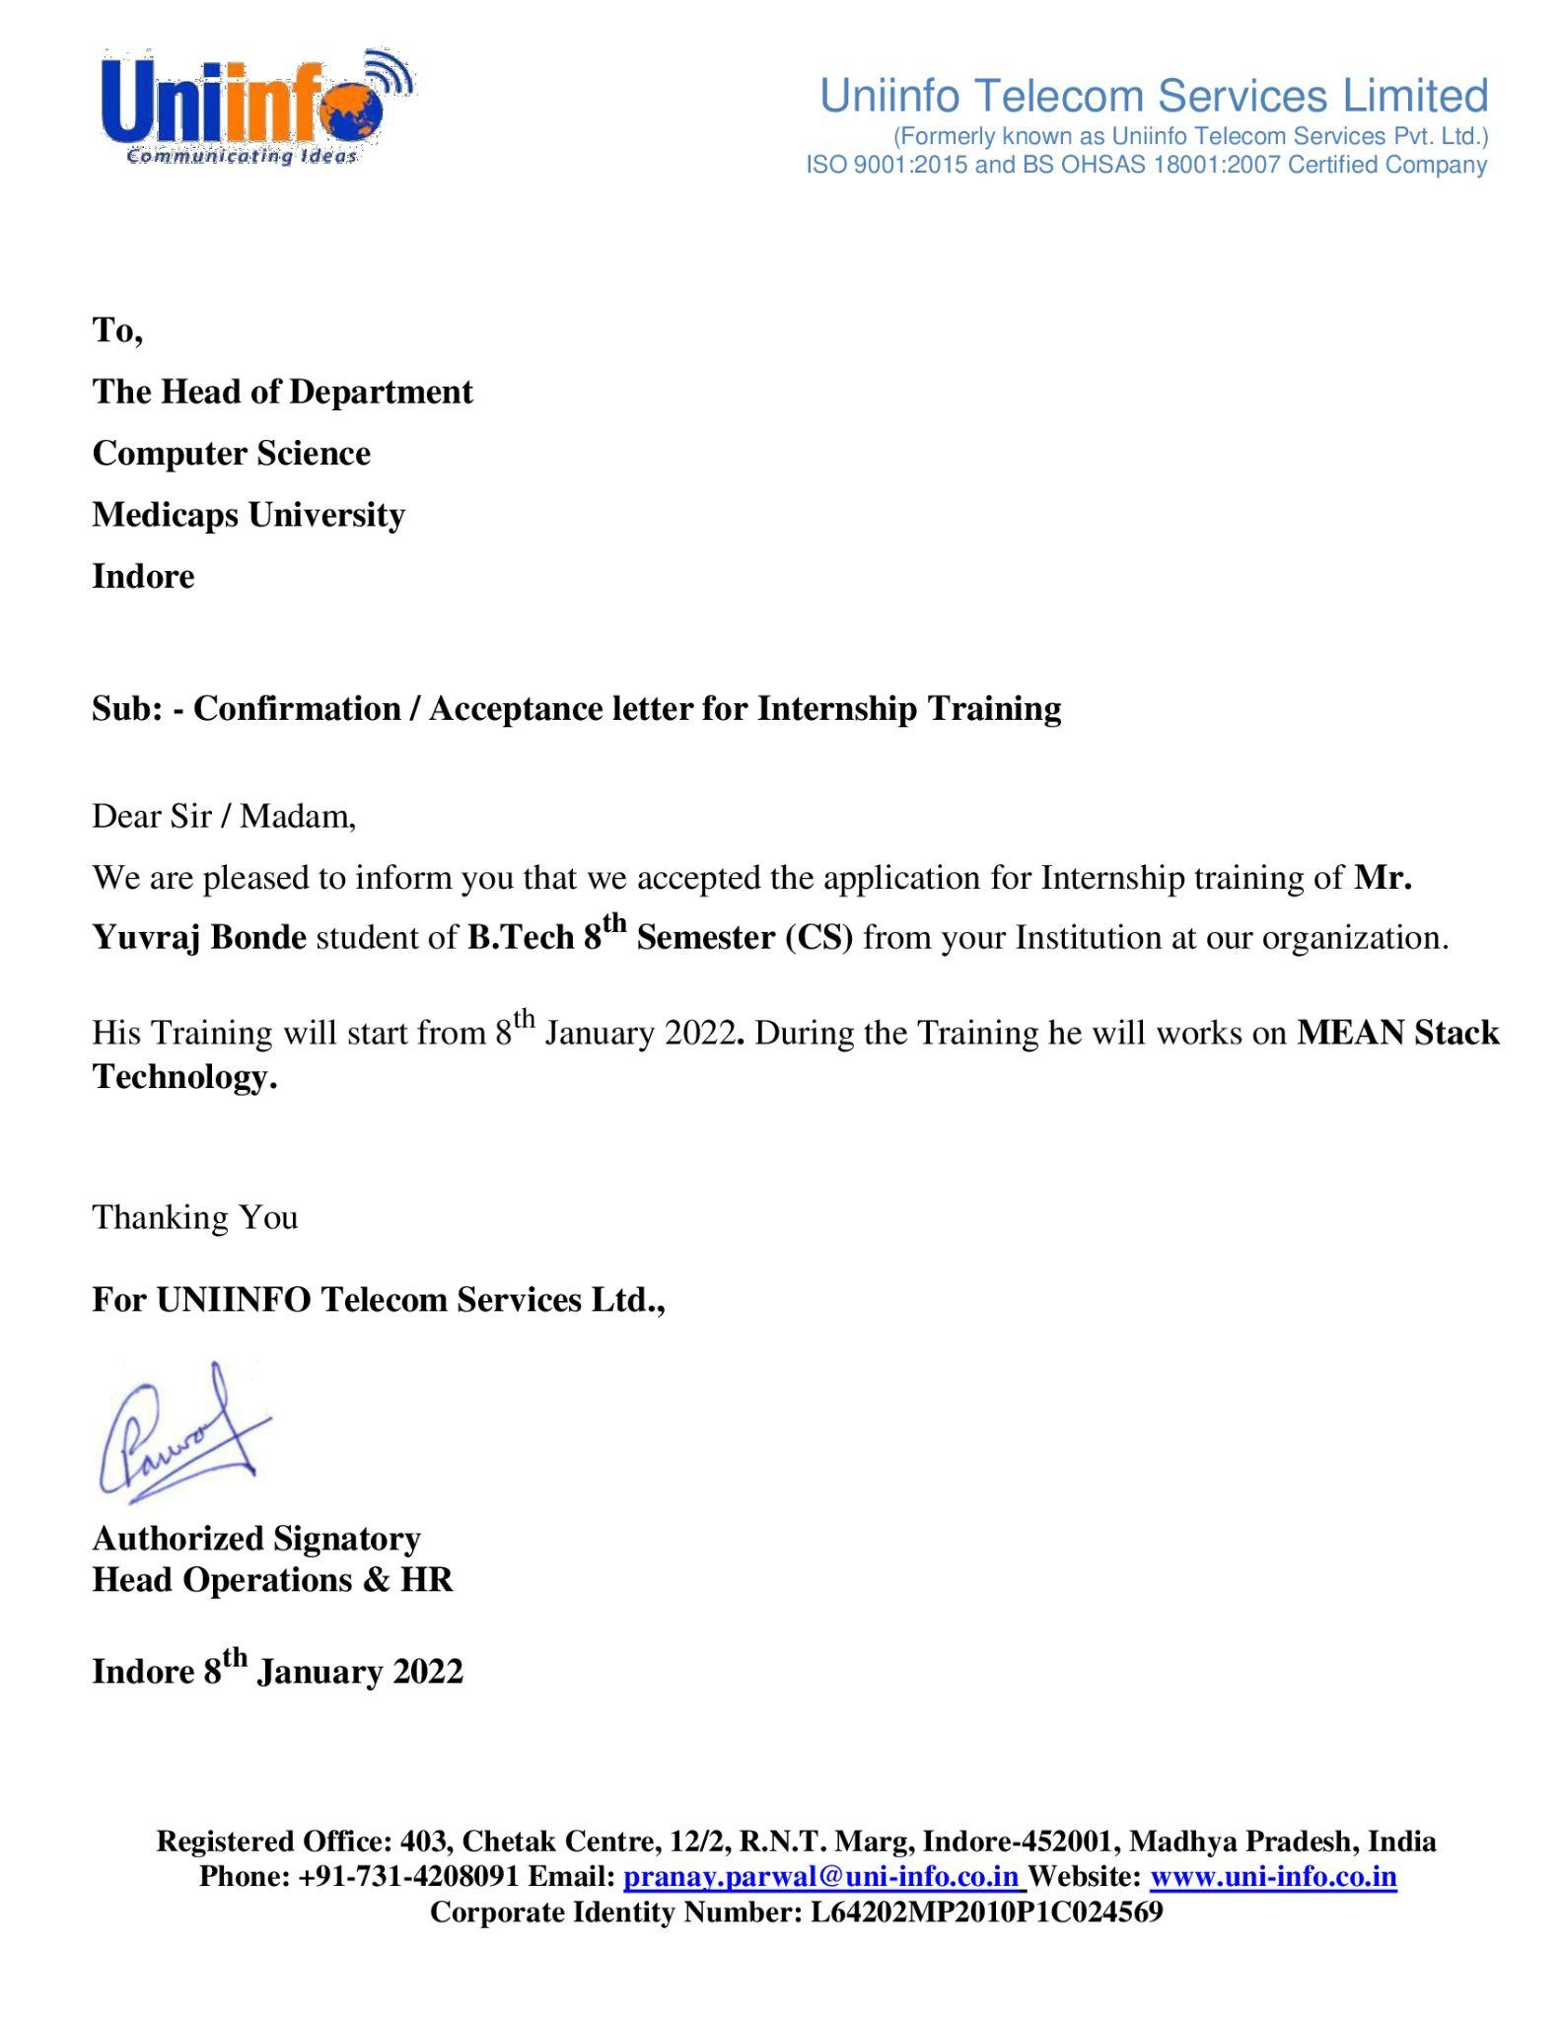

**Completion certificate/Letter**

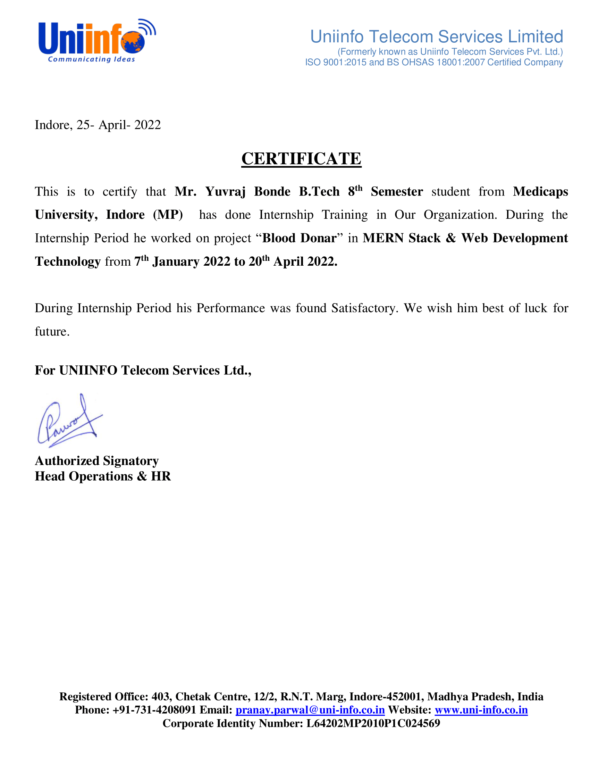

**Acknowledgements**

I would like to express my deepest gratitude to the Honorable Chancellor, **Shri R C Mittal,** who has provided me with every facility to successfully carry out this project, and my profound indebtedness to **Prof. Dr. Dilip K Patnaik,** Vice Chancellor, Medi-Caps University, whose unfailing support and enthusiasm has always boosted up my morale. I also thank **Prof. Dr. D K Panda,** Pro Vice Chancellor, **Dr. Suresh Jain,** DeanFaculty of Engineering, Medi-Caps University, for giving me a chance to work on this project. I would also like to thank my Head of the Department **Dr. Pramod S. Nair** for his continuous encouragement for betterment of the project.

I express my heartfelt gratitude to my **External Guide, Mr. Akshay Mahajan**, Project Lead, Uniinfo Telecom Services Pvt. Ltd. as well as to my Internal Guide, **Dr. Nitika Vats, Associate Professor, Department of Computer Science, MU**, without whose continuous help and support, this project would ever have reached the completion.

It is their help and support, due to which we became able to complete the design and technical report. Without their support this report would not have been possible.

**Yuvraj Bonde**

B.Tech. IV Year

Department of Computer Science & Engineering

Faculty of Engineering

Medi-Caps University, Indore

**Abstract**

As we all know, the world is suffering from the COVID-19 crisis. Our government and health care professionals are trying their best to help the patients suffering from COVID-19. Scientists are trying to discover a vaccine to cure people affected with coronavirus. There is a scientific way from which we can help to lower the death ratio or help the COVID 19 affected person. Blood Donation is an experimental approach to treat COVID-positive patients and help them recover faster. But, in this situation, it is difficult for a patient to find a blood donor as everybody can’t donate blood.

The main goal of our project is to make it easier for the COVID-19 patients to get a blood donor easily as well as donate blood if they have recovered. The system targets two types of users: the people who want to donate blood and the people who need blood. The user can also view the name, blood groups, contact no. and hospital names. The main objective of developing the website is to make it easier for the COVID-19 patients to get a blood donor easily and as soon as possible.

The person who wants to donate his/her blood needs to register in our application providing required information which are name, email id, blood group, phone number.

Patients who need blood can also fill the form to request the blood. Patients can directly call the donor by taking his/her contact number from the application.

**Table of Contents**

|  |  |  |
| --- | --- | --- |
| **Index** | **TOPIC** | **Page No.** |
|  |  |  |
|  | Report Approval | II |
|  | Declaration | III |
|  | Certificate | IV |
|  | Offer Letter of the Project work-II/Internship | V |
|  | Completion letter/certificate | VI |
|  | Acknowledgement | VII |
|  | Abstract | VIII |
|  | Table of Contents | IX |
|  | List of figures | X |
|  |  |  |
| Chapter 1 | Introduction |  |
|  | 1.1 Introduction | 1 |
|  | 1.2 Objectives | 1 |
|  | 1.3 Feasibility Study | 1-2 |
|  | 1.4 Organization | 3 |
|  |  |  |
| Chapter 2 | System Requirement Analysis |  |
|  | 2.1 Information Gathering | 4 |
|  | 2.2 Platform Specifications | 5 -7 |
|  |  |  |
| Chapter 3 | Methodology | 8 - 13 |
|  |  |  |
| Chapter 4 | Result | 14 - 16 |
|  |  |  |
| Chapter 5 | Summary and Conclusions | 17 |
|  | 5.1 Future scope | 17 |
|  |  |  |
| Chapter 6 | References | 18 |

**List of Figures**

|  |  |  |
| --- | --- | --- |
| **S.No** | **Figure Name** | **Page No.** |
| 1. | Use Case Diagram | 8 |
| 2. | Class Diagram | 9 |
| 3. | Sequence Diagram | 10 |
| 4. | Activity Diagram | 12 |
| 5. | ER Diagram | 13 |

**Chapter-1**

**1.1 INTRODUCTION**

The Blood Donation website is to create Information about the donor and organization

That is related to donating blood. Through this application any person who is interested in

Donating the blood can register him in the same way if any organization wants to register

Itself with this site that can also register. Moreover if any general consumer wants to make

Request blood online he can also take the help of this site.

The application is reduced as much as possible to avoid errors while entering the data. It also provides an error message while entering Invalid data. No formal knowledge is needed for the user to use this system. Thus by this all it proves it is user-friendly. Blood Donation, as described above, can lead to error free, secure, reliable and fast management systems. It can assist the user to concentrate on their other activities rather than concentrating on the record keeping. Thus it will help organizations in better utilization of resources.

**1.2 OBJECTIVES**

The main objective of the Project on Blood Donor is to manage the details of Blood Group, Donor, and Mobile number. It manages all the information about donors and requests came from donors. The purpose of the project is to build an application program to reduce the manual work for managing the Blood Group, Record, and Donor. It tracks all the details about the Donor, Mobile number and blood groups.

**1.3 FEASIBILITY STUDY:**

After doing the project Blood Donor, study and analyze all the existing or required functionalities of the system, the next task is to do the feasibility study for the project. All projects are feasible - given unlimited resources and infinite time.

Feasibility study includes consideration of all the possible ways to provide a solution to the given problem. The proposed solution should satisfy all the user requirements and should be flexible enough so that future changes can be easily done based on the future upcoming requirements.

**A. Economic Feasibility**

This is a very important aspect to be considered while developing a project. We decided on the technology based on the minimum possible cost factor. All hardware and software cost has to be borne by the organization. Overall we have estimated that the benefits the organization is going to receive from the proposed system will surely overcome the initial costs and the later on running cost for the system.

**B. Technical Feasibility**

This included the study of function, performance and constraints that may affect the ability to achieve an acceptable system. For this feasibility study, we studied complete functionality to be provided in the system, as described in the System. Requirement Specification (SRS), and checked if everything was possible using different types of frontend and backend platforms.

**C. Operational Feasibility**

No doubt the proposed system is fully GUI based and is very user friendly and all inputs to be taken are all self-explanatory even to a layman. Besides, proper training has been conducted to let the users know the essence of the system so that they feel comfortable with the new system. As far our study is concerned the clients are comfortable. and happy as the system has cut down their loads and doing.

**1.4 ORGANIZATION:**

Medi-Caps have been a brand name in the arena of technical education. Since its inception in July 2000, Medi-Caps have consistently aimed at creating an ideal ambiance for budding technocrats and managers; and helping them to grow like true professionals. With its highly qualified faculty there seems an optimal blend of academic brilliance and industry exposure, supplemented by highly specialized visiting faculty and industry experts, senior professionals from various segments of different industries and business houses. It was time now to spread wings and move out for more exposure and widening of the periphery.

Hence the foundation of Medi-Caps University has been laid down. With a strong foundation of the Group for 15 years, Medi-Caps University wishes to maintain the same objective of imparting quality education and producing sound professionals for the benefit of the society at large.

**Chapter 2**

**SYSTEM REQUIREMENT ANALYSIS**

**2.1 INFORMATION GATHERING**

## Functional Requirements

* **Access Website:** Software operators should be capable of accessing web-application through either an application browser or similar service on the PC. There should not be any limitation to access web-application.
* **Software operator Registration:** Given that software operator has accessed web-application, and then the software operator should be able to register through the web-application. The donor software operator must provide first name, gender, blood or plasma group, contact, and password.
* **View Request:** The Blood or plasma Bank should be able to view received requests and then respond to them and can search requests by selecting two options: select blood or plasma group and provision.

## Non-Functional Requirements

* **Maintainability:** The Blood Donor must have a high level of Maintainability.
* **Serviceability:** If an issue arises in the Blood Donor, then the project must be programmed in such a way that the developer can service it again.
* **Environmental:** The Blood Donor must be working in the latest operating system environments like windows 7, windows 8, and windows 10 and on Linux.

**2.2 PLATFORM SPECIFICATIONS**

**2.2.1 Hardware Requirements:**

* Processor - Minimum Intel Core i3
* RAM - 4 GB
* Hard Disk - 500 GB

**2.2.2 Software Requirements:**

* Operating System: All Applicable.
* Technology: HTML, CSS, JavaScript, Node JS, Express JS, MongoDB.
* Tool - Visual Studio Code.

**Software Implementation Technology:**

1. **HTML:** HTML is an acronym which stands for Hyper Text Markup Language which is used for creating web pages and web applications. Let's see what is meant by Hypertext Markup Language, and Web page.

* **Hypertext:** Hypertext simply means "Text within Text." A text has a link within it, is a hypertext. Whenever you click on a link which brings you to a new webpage, you have clicked on a hypertext. Hypertext is a way to link two or more web pages (HTML documents) with each other.
* **Markup language:** A markup language is a computer language that is used to apply layout and formatting conventions to a text document. Markup language makes text more interactive and dynamic. It can turn text into images, tables, links, etc.
* Hence, **HTML** is a markup language which is used for creating attractive web pages with the help of styling, and which looks in a nice format on a web browser. An HTML document is made of many HTML tags and each HTML tag contains different content.

1. **CSS:** CSS stands for **Cascading Style** **Sheets**. It is a style sheet language which is used to describe the look and formatting of a document written in markup language. It provides an additional feature to HTML. It is generally used with HTML to change the style of web pages and user interfaces. It can also be used with any kind of XML documents including plain XML, SVG and XUL.

**CSS** is used along with HTML and JavaScript in most websites to create user interfaces for web applications and user interfaces for many mobile applications.

1. **JavaScript:** JavaScript (js) is a light-weight object-oriented programming language which is used by several websites for scripting the webpages. It is an interpreted, full-fledged programming language that enables dynamic interactivity on websites when applied to an HTML document. It was introduced in the year 1995 for adding programs to the webpages in the Netscape Navigator browser. Since then, it has been adopted by all other graphical web browsers. With JavaScript, users can build modern web applications to interact directly without reloading the page every time. The traditional website uses js to provide several forms of interactivity and simplicity.
2. **Node JS:** Node.js is a cross-platform runtime environment and library for running JavaScript applications outside the browser. It is used for creating server-side and networking web applications. It is open source and free to use. Many of the basic modules of Node.js are written in JavaScript. Node.js is mostly used to run real-time server applications.
3. **Express JS:** Express is a fast, assertive, essential and moderate web framework of Node.js. You can assume express as a layer built on the top of the Node.js that helps manage a server and routes. It provides a robust set of features to develop web and mobile applications.
4. **MongoDB:** MongoDB is an open-source document database that provides high performance, high availability, and automatic scaling. In simple words, you can say that - Mongo DB is a document-oriented database. It is an open source product, developed and supported by a company named 10gen.
5. **Visual Studio Code:** Visual Studio Code is a code editor in layman's terms. Visual Studio Code is “a free-editor that helps the programmer write code helps in debugging and corrects the code using the intelli-sense method”. In normal terms, it facilitates users to write the code in an easy manner.

Visual Studio Code is a lightweight but powerful source code editor which runs on your desktop and is available for Windows, macOS and Linux. It comes with built-in support for JavaScript, Typescripts and Node.

**Chapter 3**

**METHODOLOGY**

The person who wants to donate his/her blood needs to register in our application providing required information which are name, email id, blood group, phone number. Patients who need blood can also fill the form to request the blood. Patients can directly call the donor by taking his/her contact number from the application.

* **USE CASE DIAGRAM:** Use-case diagrams describe the high-level functions and scope of a system. These diagrams also identify the interactions between the system and its actors. The use cases and actors in use-case diagrams describe what the system does and how the actors use it, but not how the system operates internally.

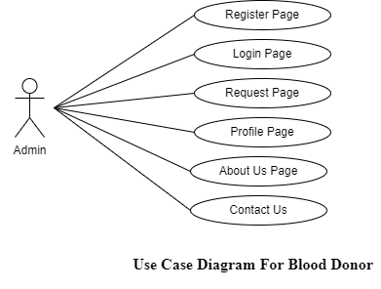

**Fig 1- USE CASE DIAGRAM**

* **CLASS DIAGRAM:** A class diagram is an illustration of the relationships and source code dependencies among classes in the Unified Modeling Language (UML). In this context, a class defines the methods and variables in an object, which is a specific entity in a program or the unit of code representing that entity.

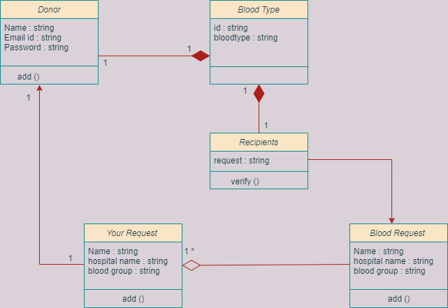

**Fig. 2- CLASS DIAGRAM**

* **SEQUENCE DIAGRAM:** A sequence diagram is a type of interaction diagram because it describes how—and in what order—a group of objects works together. These diagrams are used by software developers and business professionals to understand requirements for a new system or to document an existing process.

**Here, Sequence diagram for Registration users:**

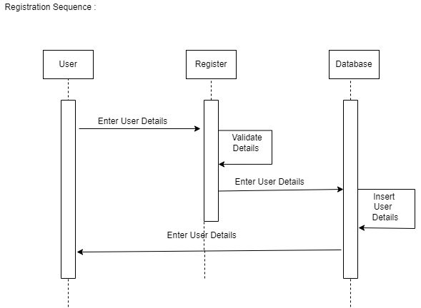

**Fig. 3 - Sequence Diagram for Registration**

* **Here, Sequence diagram for the request donor:**

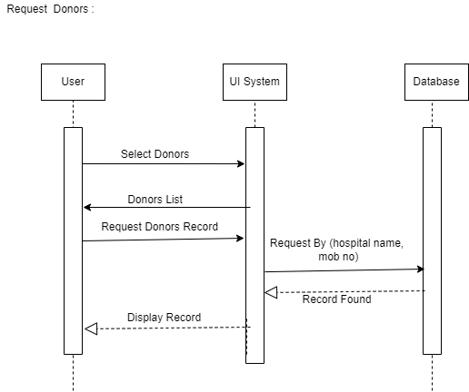

**Fig. 4 - Sequence Diagram for Request**

* **Activity Diagram:** An activity diagram visually presents a series of actions or flow of control in a system similar to a flowchart or a data flow diagram. Activity diagrams are often used in business process modeling. They can also describe the steps in a use case diagram.

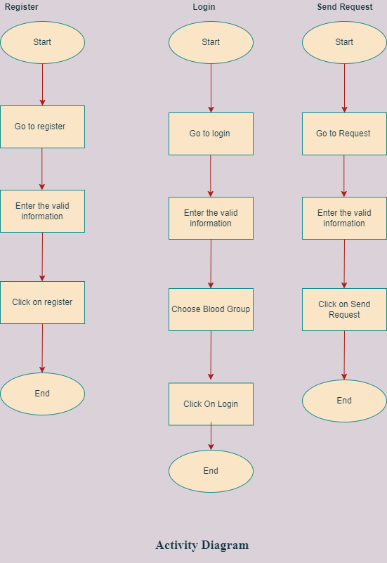

**Fig. 5 - Activity Diagram**

* **E-R DIAGRAM:** ER-Diagram is a pictorial representation of data which describes how the data is communicated and related to one another. Any object, like entities, attributes of an entity, sets of relationship and other attributes of relationship are characterized with the help of the ER diagram.

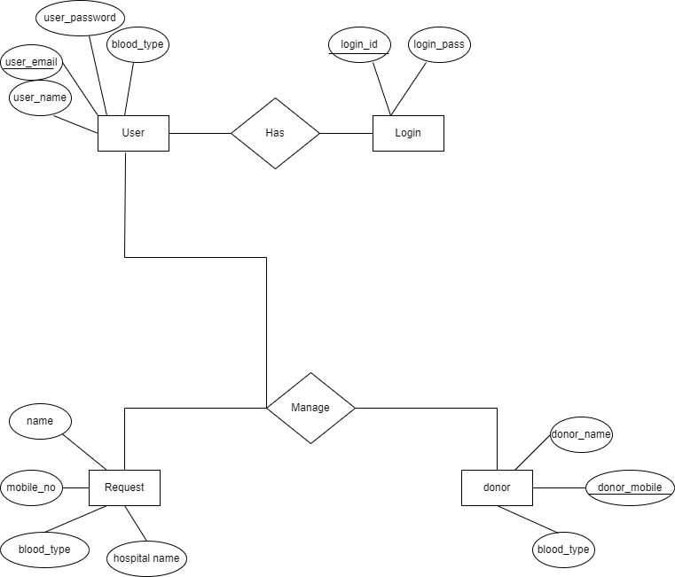

**Fig. 6 - E-R Diagram**

**Chapter 4**

**RESULTS**

While after doing this dummy project first I downloaded a template and then edited by html and css by doing the frontend part first. Then came the backend part by doing coding and after that I had connected to the database in mongo db.

Here, the Screenshots of the Project:

* **Home Page:**

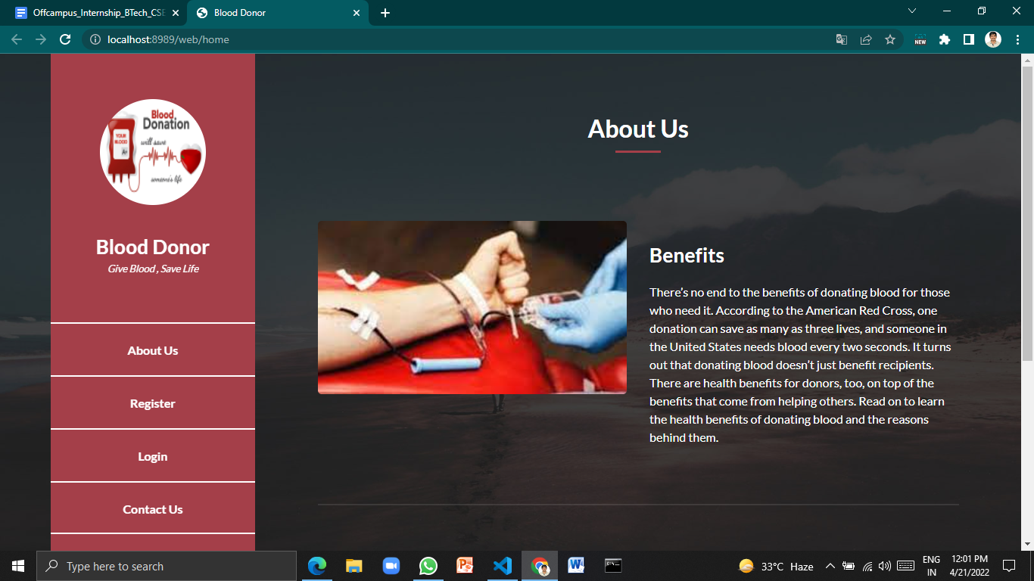

* **Registration Page**

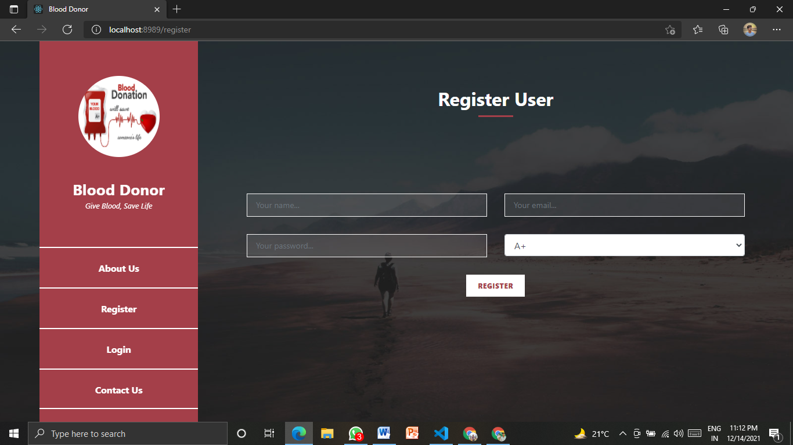

* **Login Page:**

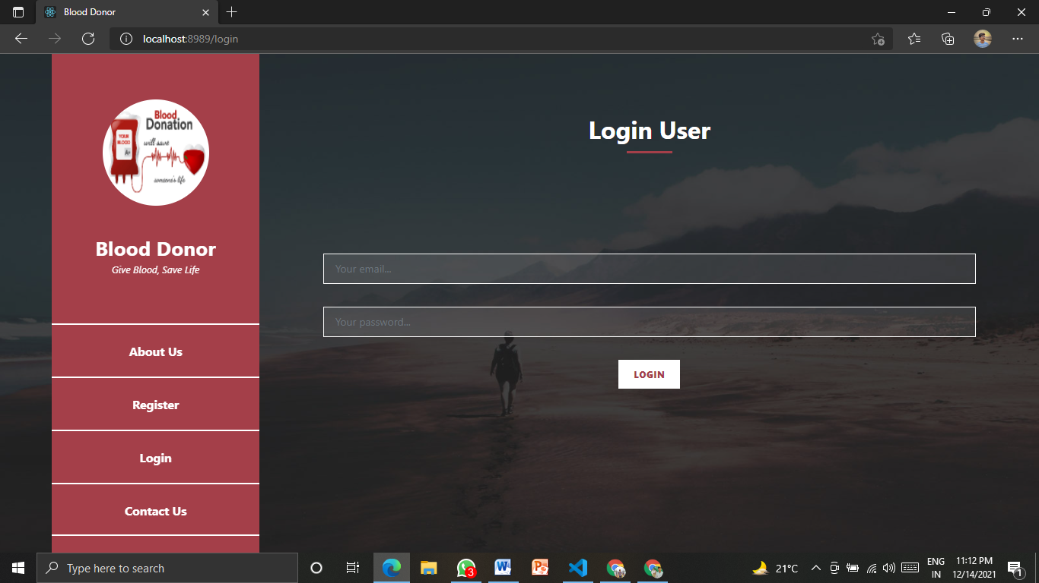

* **Request Page:**

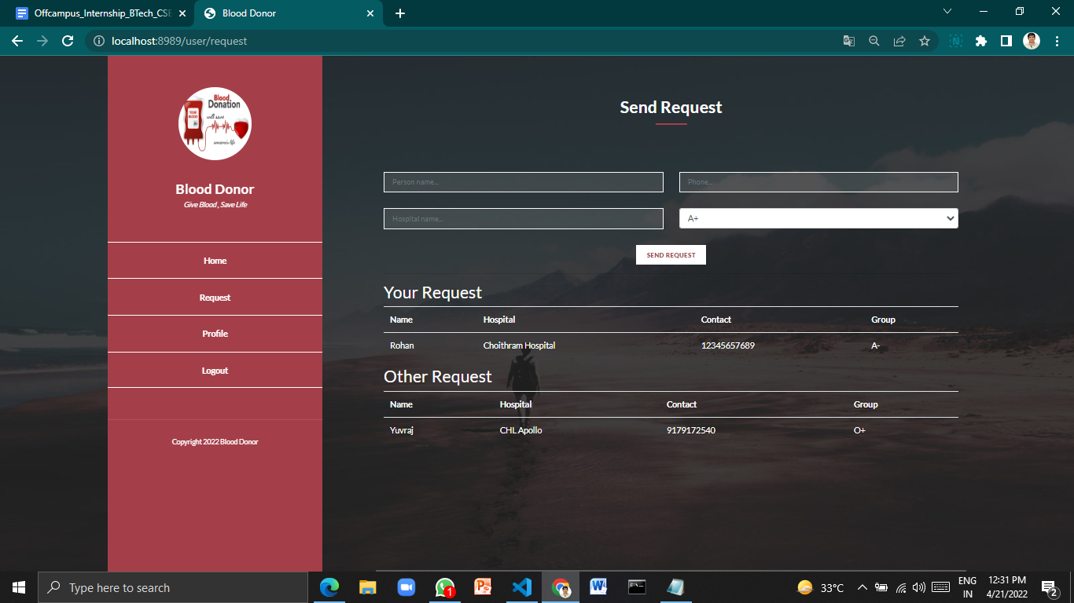

* **Database Connected:**

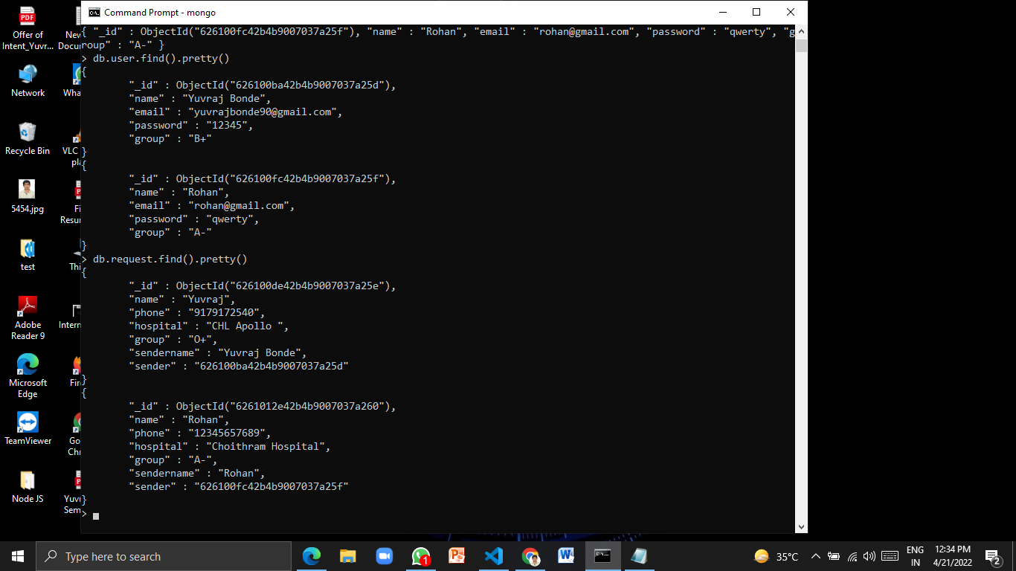

**Chapter 5**

**SUMMARY AND CONCLUSIONS:**

**Summary:**

This is a Web Based Application of Blood Donor in which users can donate blood and also request the blood. First you can register yourself with the help of your email id and blood group then you can sign in and request your blood group or donate. In the same way the other users can see your request and contact you within minutes with the help of contact number. In this Application database is also connected and the data is shown in mongo db. where all the data had stored in this application.

**Conclusions:**

Universally ,blood is recognized as the most important element that saves life .It saves countless number of lives across in various circumstances .In today's world, where we can do many things from home, by just pressing one click we can take advantage of that concept by making online solution for the shortage of blood donors. The blood donor helps to reduce use of papers, so the probability of errors should be minimal. This web based system is a small contribution to society. It can save lives by encouraging the public to donate blood, manage records of donors and people who need blood, to help those who need blood to find appropriate donors as soon as possible in a quick, perfect and a safe way with less effort.

**5.1 Future Scope:**

* In future email verification will have to be added for registration of users.
* Other organs also we can add in this for future.
* Payment option also we give in future.

**Chapter 6**

**REFERENCES**

**1. NodeJS documentation:-**

[**https://nodejs.org/dist/latest-v14.x/docs/api/**](https://nodejs.org/dist/latest-v14.x/docs/api/)

**2. ExpressJS documentation:-**

[**https://expressjs.com/en/starter/installing.html**](https://expressjs.com/en/starter/installing.html)

**3. MongoDB:-**

[**https://docs.mongodb.com/manual/tutorial/getting-started/**](https://docs.mongodb.com/manual/tutorial/getting-started/)

**4. Javatpoint:-**

[**https://www.javatpoint.com/html-tutorial**](https://www.javatpoint.com/html-tutorial)

**5. Stack Overflow**

**6. YouTube**

**7. Wikipedia**